Date:

TASK 8: Grover’s algorithm for a 3-qubits database

Aim: To implement Grover’s quantum search algorithm for a 3-qubit search space (8 items) using Cirq, and demonstrate that the marked item (target state) can be found with high probability after the optimal number of iterations.

1 Mathematical Model of the Grover’s algorithm for a 3-qubits database

Database size: Search space = 2 = 8 elements represented by 3-qubit basis states {∣000 ,∣001 ,…,∣111 }.

Target: A basis state |w , here chosen as |101 .

 | Initial State: Equal superposition | ∣ S = | 1 | N−1 | (∣ x ) = | 1 | 7
 | Initial State: Equal superposition | ∣ S = | N | ∑x=0 | (∣ x ) = | ∑_{x=0}(∣ x ) created by
 |  |  | N |  |  | 8

applying Hadamard gates on all 3 qubits.

Oracle: f(x) = 1 if x = x′ (the “marked” target), 0 otherwise.

Diffusion operator: Inversion about the mean, realized by Hadamard gates, X gates, multi-controlled Z, and reversing these gates.

Grover operator: G = D.O.
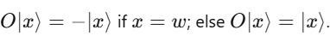
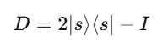

Grover Iterations: Apply oracle + diffusion operator approximately = times to

amplify the amplitude of the marked state.

For N = 8, M=1, r = 2.

Measurement: Measurement of all qubits follows iterations, producing bit strings with probability concentrated on the marked state.

2 Algorithm - Grover’s algorithm for a 3-qubits database

- Initialize 3 qubits to ∣0 .

- Create uniform superposition by Hadamard gates H⊗3.

- Repeat k = 2 times:

- Apply oracle marking the target bit string with phase flip on the marked state.
  - Apply diffusion operator (inversion about the mean).

- Measure the qubits to obtain results peaked at the target state with high probability.

3 Program

import cirq
import numpy as np
import matplotlib.pyplot as plt

def grover_3_qubit(target_binary):
qubits = [cirq.GridQubit(0, i) for i in range(3)]
circuit = cirq.Circuit()

- Initialize superposition circuit.append(cirq.H.on_each(*qubits))
- Removed: circuit.append(cirq.Barrier(*qubits)) # Barrier after initialization

- Number of Grover iterations

N=2**3
iterations = int(np.floor(np.pi/4 * np.sqrt(N)))

for iteration in range(iterations):
# Oracle
apply_oracle(circuit, qubits, target_binary)
- Removed: circuit.append(cirq.Barrier(*qubits)) # Barrier after oracle

- Diffusion
apply_diffusion(circuit, qubits)
  - Removed: circuit.append(cirq.Barrier(*qubits)) # Barrier after diffusion

- Measurement
circuit.append(cirq.measure(*qubits, key='result'))

return circuit, qubits

def apply_oracle(circuit, qubits, target_binary):
- Apply X gates where target bit is 0 for i, bit in enumerate(target_binary):
if bit == '0': circuit.append(cirq.X(qubits[i]))

- Multi-controlled Z using H and CCX circuit.append(cirq.H(qubits[-1])) circuit.append(cirq.CCX(qubits[0], qubits[1], qubits[2])) circuit.append(cirq.H(qubits[-1]))

# Undo X gates
for i, bit in enumerate(target_binary):
if bit == '0':
circuit.append(cirq.X(qubits[i]))

def apply_diffusion(circuit, qubits): circuit.append(cirq.H.on_each(*qubits)) circuit.append(cirq.X.on_each(*qubits)) circuit.append(cirq.H(qubits[-1])) circuit.append(cirq.CCX(qubits[0], qubits[1], qubits[2])) circuit.append(cirq.H(qubits[-1])) circuit.append(cirq.X.on_each(*qubits)) circuit.append(cirq.H.on_each(*qubits))

def analyze_results(counts, target):
total = sum(counts.values())
success = counts.get(int(target, 2), 0)
success_rate = success / total * 100

print(f"Measurement results for target |{target}>:")
for state in range(8):
bitstr = format(state, '03b')
count = counts.get(state, 0)
pct = count / total * 100
marker = "<-- Target" if bitstr == target else ""
print(f"State |{bitstr}>: {count} times ({pct:.2f}%) {marker}")

print(f"\nSuccess rate: {success_rate:.2f}% (optimal ~94% after 2 iterations)")

states = [format(i, '03b') for i in range(8)]
values = [counts.get(i, 0) for i in range(8)]
colors = ['red' if s == target else 'blue' for s in states]

plt.bar(states, values, color=colors)
plt.title(f"Grover's Algorithm Results (Target: |{target}>)")
plt.xlabel("States")
plt.ylabel("Counts")
plt.show()

if __name__ == "__main__":
target = "101"
circuit, qubits = grover_3_qubit(target)

print("Circuit diagram:")
print(circuit)
simulator = cirq.Simulator()
result = simulator.run(circuit, repetitions=1000)
counts = result.histogram(key='result')

analyze_results(counts, target)

output:
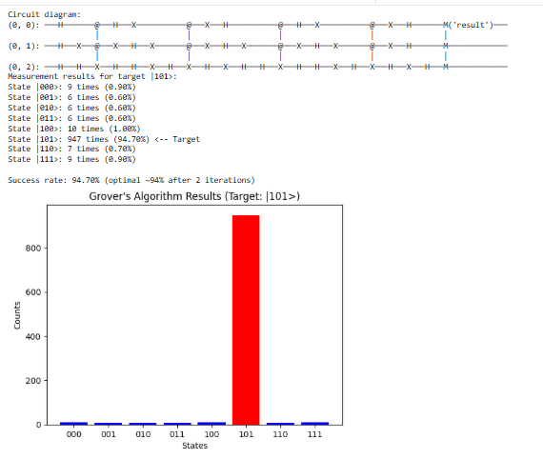

4 Result

The successful implementation of Grover's algorithm for a 3-qubit database validates the theoretical foundations of quantum search algorithms and provides a practical demonstration of quantum computing potential for solving problems more efficiently than classical computers

